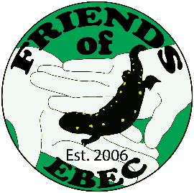
FRIENDS OF THE EAST BRUNSWICK ENVIRONMENTAL COMMISSION
501c-3 nonprofit organization
9 Camelot Drive
East Brunswick, New Jersey, 08816, USA

Friends.ebec@gmail.com
Friendsebec.com

Contact: Sandy Lanman
sandra.lanman@gmail.com

Learn About the Whales of New York and New Jersey
With Rutgers Researcher Danielle Brown in Virtual Program, March 22

EAST BRUNSWICK -- Whales have been in the news lately, mainly because so many have been found dead or dying along the coasts of several mid-Atlantic states, including New Jersey. What’s happening to them and what are the major threats to these beautiful and important sea mammals?

Join Rutgers whale researcher Danielle Brown in a virtual program via Zoom at the East Brunswick Public Library at 7 p.m., Wednesday, March 22, as she discusses the baleen whales found in the coastal waters of New York and New Jersey, past and present. Brown will focus on humpback whales, including their increasing presence in the region and risks to them from anthropogenic, or human-caused, activity. She will take questions following her presentation.

To access the Zoom program go online to the library’s events calendar at ebpl.org, or click on this link.

Brown is a Ph.D. candidate at Rutgers University and is the director of research for Gotham Whale. Her research focuses on the ecology of humpback whales off New York and New Jersey, including their population characteristics and risks from vessel strike.

This program is part of the Option Green series coordinated by the Friends of the East Brunswick Environmental Commission in partnership with the East Brunswick Public Library.

For more information about FriendsEBEC and to join the email list for program updates, go to friendsebec.com.

###

